Page Rank, Closeness (Latora), Degree, eigenvector, authority, hubscore, Betweenness, DMNC, Lobby Index, Leverage, Eccentricity, Information Centrality, Local Bridging

**Pagerank**

**Degree**

*deg*(*v*)=|N(*v*)|

**Eigenvector**

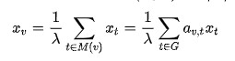

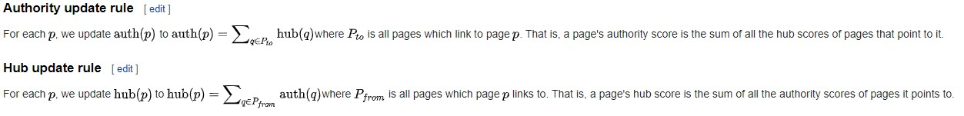**Authority and hubscore**

**Betweenness**

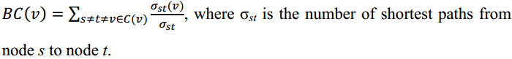

**DMNC**

*DMNC*(*v*) = |*E*(*MC*(*v*))|/ |*V*(*MC*(*v*))|*ε*

**Lobby Index**

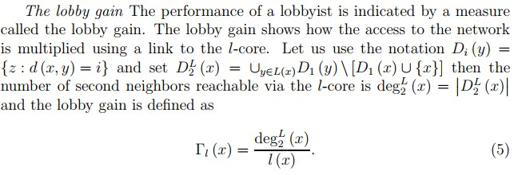

**Leverage**

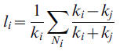

**Eccentricity**



**Information Centrality**



**Local Bridging**

